Overview: Use this general lab rubric to assist you in determining how to go about writing your report. You should always strive to be “Proficient” in your writing. Though in-class labs are done in pairs or groups, you are responsible for writing your own unique lab report – hypotheses, methods, and results may be similar, but should be written in your own words. Therefore, all members of a lab group must turn in their own report. Any report(s) turned in that have been copied or plagiarized will receive a 0 grade and may be subject to disciplinary referral. You will receive graded labs with a condensed version of this rubric along with your work to store in your portfolio. Use the following descriptions to aid in understanding your feedback.

Introduction: Why is this question important/necessary to understanding statistics? What background information does the reader need to know to understand the statistics outlined in this report?
Not Addressed – 0 points | Novice – 1 point | Intermediate – 2 points | Proficient – 3 points
Importance of question not addressed; background info is missing or contains major inaccuracies; background info presence but irrelevant; references to class literature absent | Generic or vague rationale for importance of the question; background omits info or contains inaccuracies that detract from the major point; background info only partially relevant; references inadequately explained | Provides one explanation of the importance of the topic at hand; Background info may contain minor omissions or inaccuracies that do not detract from major point; background info has appropriate level of specificity to provide relevancy; references relevant and adequately explained but few | Clear sense of why this knowledge may be important to a broader audience; Background info completely accurate; Background info is appropriately specific and provides concise and useful context to aid understanding; references are relevant, adequately explained, and indicate thorough practice

Hypotheses: Clearly stated and testable, with plausible alternatives explained. If instructor designed, explanations of the hypotheses and why they are stated as such.
Not Addressed – 0 points | Novice – 1 point | Intermediate – 2 points | Proficient – 3 points
No hypothesis indicated; hypothesis stated by too vague or confused to be useful; hypothesis clearly stated by not testable; hypothesis clearly stated, but trivial | A single relevant, testable hypothesis is clearly stated | Adequate number of relevant, testable hypotheses clearly stated; hypotheses address more than one major potential mechanism, explanation, or factors for the topic | A comprehensive suite of testable hypotheses are clearly stated which, when tested, will distinguish among multiple major factors or potential explanations for phenomena at hand.

Methods:
- Student designed – Experimental design is likely to produce salient and fruitful results (tests the hypotheses posed). Appropriate controls are present and explained.
- Instructor designed – Explanation of why the experimental design is appropriate; Explanation of directions and why they are useful in determining the ultimate question.
Not Addressed – 0 points | Novice – 1 point | Intermediate – 2 points | Proficient – 3 points
Design (or explanation of) is poorly explained, inappropriate, or indecipherable; Controls (or explanation of) nonexistent, or present and not described or inappropriate | Design (or explanation of) is appropriate, clearly explained, but not modified where appropriate or drawn from coursework; Controls (or explanation of) consider one major relevant factor. | Design (or explanation of) is appropriate, clearly explained, and modified from coursework appropriately; Controls (or explanation of) take most relevant factors into account | Design (or explanation of) is appropriate, clearly explained, and is a synthesis of multiple previous approaches; Controls (or explanation of) considers all relevant factors and have become methods of differentiating between multiple hypotheses.

Results: Data are summarized in a logical format. Tables or graph types are appropriate and properly labeled, scaled, and captioned. Statistical analysis is appropriate and correctly performed to achieve ideas in question. Analysis is appropriately interpreted with relevant values and explained thoroughly.
Not Addressed – 0 points | Novice – 1 point | Intermediate – 2 points | Proficient – 3 points
Data are incomplete or haphazard to provide reasonable basis for testing; statistical analysis missing or performed incorrectly; labels/units missing; presentation of data is inappropriate; captions confusing or indecipherable | At least one relevant dataset (if not given) per hypotheses (or question) is provided but some necessary data are missing or inaccurate; appropriate statistical analysis provided, but lacks sufficient explanation; presentation is technically correct but inappropriate; contains some errors or omissions in labels or scales | Data are relevant, accurate, and complete with any gaps being minor; appropriate statistical analysis performed and reasonably well explained; presentation contains only minor mistakes; presentation types are appropriate | Data are relevant, accurate and comprehensive; data may be synthesized or manipulated in a novel way to provide additional insight; statistical analysis is appropriate, correct, and clearly explained; presentation contains no mistakes; presentation is elegant, insightful, concise, and overall appropriate

Discussion: The paper, first and foremost, must answer all questions outlined in the lab directions, pulling from primary literature (textbook, notes/lecture, etc.). Conclusions must be clearly and logically drawn from data provided, following a logical chain of reasoning. Conflicting data if present, are adequately addressed. Exceptional papers will also ask questions that the lab did not answer.
Not Addressed – 0 points | Novice – 1 point | Intermediate – 2 points | Proficient – 3 points
No questions answered, or some answered but with blatant inaccuracies; conclusions have little or no basis in data provided; non-existent or limited connection between sections of paper; conflicting data not addressed; no further questions posed; no or inappropriate reference to primary resources | Most questions posed are answered, or all questions are answered, but with inaccuracies; conclusions have some direct basis in data but may contain gaps in logic or are overly broad; weak connections throughout points of paper; conflicting data poorly addressed or missing; no or irrelevant questions posed; little or inadequate reference of primary resources | All questions posed are answered adequately; conclusions are clearly and logically drawn from data with reasonable chain and logic throughout paper; conclusions attempt to discuss or explain conflicting data; some questions about data posed; reference to primary resources present with adequate reasoning | All questions posed are answered to the fullest extent; conclusions are completely justified by data; connections between sections of paper are comprehensive and persuasive; explanation of conflicting data clearly addressed with ample reasoning; insightful questions about the data posed; reference to primary resources displays overt understanding of material

Writing Quality: Grammar, word usage and organization facilitate the reader’s understanding of the paper.
Not Addressed – 0 points | Novice – 1 point | Intermediate – 2 points | Proficient – 3 points
Grammar and spelling errors detract from the meaning of the paper; word usage is frequently confused or incorrect, information is presented in a haphazard way. | Grammar and spelling mistakes do not hinder the meaning of the paper; general world usage is appropriate, thought technical language may have occasional mistakes; some evidence of an organizational strategy. | Grammar and spelling have few mistakes; word usage is accurate and aids the reader’s understanding; distinct sections of the paper are delineated by informative subheadings; a clear organizational strategy is present with a logical progression of ideas | Correct grammar and spelling; word usage facilitates reader’s understanding; informative subheadings significantly aid reader’s understanding; a clear organizational strategy is present with a logical progression of ideas; this paper is easier to read than most.

Instructor Comments:

Points Earned: _______ / _______

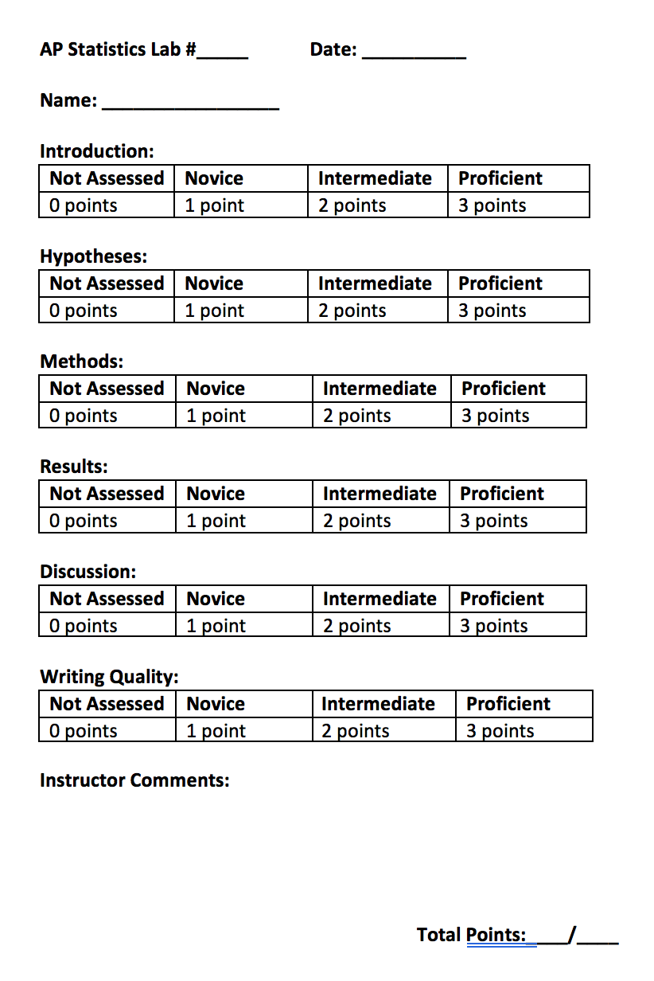

AP Statistics Lab #_____ Date: __________

Name: _________________

Introduction:
Not Assessed | Novice | Intermediate | Proficient
0 points | 1 point | 2 points | 3 points

Hypotheses:
Not Assessed | Novice | Intermediate | Proficient
0 points | 1 point | 2 points | 3 points

Methods:
Not Assessed | Novice | Intermediate | Proficient
0 points | 1 point | 2 points | 3 points

Results:
Not Assessed | Novice | Intermediate | Proficient
0 points | 1 point | 2 points | 3 points

Discussion:
Not Assessed | Novice | Intermediate | Proficient
0 points | 1 point | 2 points | 3 points

Writing Quality:
Not Assessed | Novice | Intermediate | Proficient
0 points | 1 point | 2 points | 3 points

Instructor Comments:

Total Points:____/____

